INTRODUCTION:

This is a Requirements Specification document for a new web-based & application-based online purchasing car system, Inc. (NAH motors). NAH motors is a store for selling cars. The new system will upgrade the store to **provide the company a new market and it is an online purchasing system to make it easier for the user to register cars without having to come to the store. In our website the user login by his email and password if he has an account if he doesn’t have he will sign up by his name, email, password. The user can view cars or new cars and select a car he wants, then he can register for a date to come and see the car he selected. The user can view store location or write his feedback or knowing about us or logout.**

Problem definition:

# 1-the user communication would go to some hard levels through

# out product implementation as he may not have enough time as we want or may have some communication issues.

# 2-our quality is number on concern and that may lead to over

# pricing our product.

# valuable quality may be affected or needed to be lowered.

# 4-we may face some time management issues as it may be due to external issue, political, weather changing, or internal, company closing, employee’s non-commitment, so it will affect

# our time plan.

# Project functionality:

our website allows registered users to be able to select car or new car from our car collection, every car well defined in our website to help user to select his appropriate car. the user can register for date to come and see the car he selected, then The user can write his feedback about our website or knowing about us or view store location or logout.

Technical functionality:

our website has form validation functionality, connects to databases

ERD:

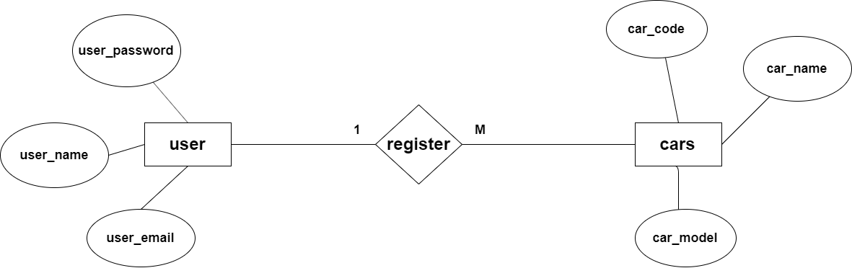

* + Existence of a coherent HTML, CSS (Bootstrap), JavaScript, PHP.
  + Also the functionalities such as Sessions, Validation, Communication with database is important.
  + Teamwork has is important and will have a weight too.